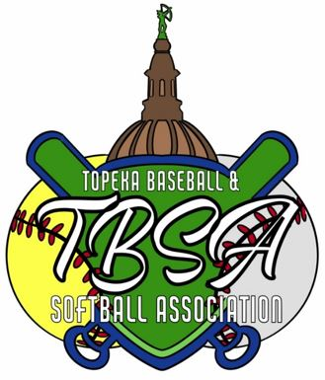
Topeka Baseball and Softball Association

Topeka, Kansas ○ established 2014

Website: www.topekabaseballandsoftball.com
Email: topekabaseballsoftball@gmail.com

MANAGER CHECKLIST * ALL* AGE DIVISIONS

Team Name: ______________________ Coach Name: ______________________ Division: ___________________
(age group)
 | Volunteer Packet:  - Volunteer Application & Registration  (Shawnee County Parks and Recreation Athletic Department will perform Volunteer Screening)  - Pledge of Good Sportsmanship (signed)
   | Volunteer Name  (printed name) | Phone Number | County Consent release | Sports-manship  Pledge | SCPR  Approved? | Board of Director  Initials
  1 |  |  |  |  | Y N
  2 |  |  |  |  | Y N
  3 |  |  |  |  | Y N
  4 |  |  |  |  | Y N
  5 |  |  |  |  | Y N
  6 |  |  |  |  | Y N
  7 |  |  |  |  | Y N
  8 |  |  |  |  | Y N
  9 |  |  |  |  | Y N
  10 |  |  |  |  | Y N
  11 |  |  |  |  | Y N
  12 |  |  |  |  | Y N
  13 |  |  |  |  | Y N
  14 |  |  |  |  | Y N

 | Team Rosters:  - TBSA Team Roster (two copies) must be typed or printed. One copy for league office one copy is for the coach.
IMPORTANT NOTE: Blank team rosters can be downloaded and keyed from the TBSA website using (Microsoft Word) if a manager chooses to he/she can then email those rosters to: topekabaseballsoftball@gmail.com instead of printing copies.

